
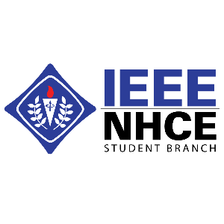
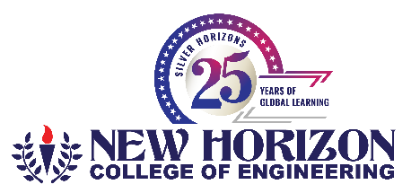
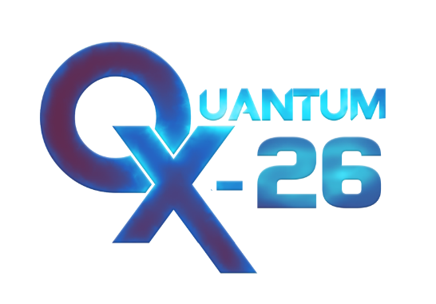
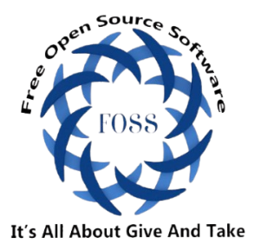

WORKSHOP – “Agentic AI”

Title : WORKSHOP
Nature of the Event : Technical Workshop
Date : 26.03.2026 – 28.03.2026
Time : 10:00 AM TO 5:00 PM
Resource Persons : Mr. Shri Dahran, Mr. Prasana.V
Total no. of participants: 50

Brief Report:
Workshop Report: QuantumX 2026 – Agentic AI
The QuantumX 2026 event, conducted at New Horizon College of Engineering, featured a workshop on the rapidly evolving domain of Agentic Artificial Intelligence as one of its key sessions. The workshop was organized in collaboration with the FOSS Club, whose student members coordinated closely with the QuantumX team to ensure its successful execution. The primary objective of the workshop was to provide participants with both theoretical knowledge and practical exposure to AI systems capable of autonomous decision-making and goal-driven actions.
The session commenced with an introduction to the fundamentals of Agentic AI, explaining how it extends beyond traditional AI models by enabling systems to act independently, adapt to dynamic environments, and perform complex multi-step tasks. The speakers elaborated on key concepts such as intelligent agents, decision-making frameworks, memory, planning, and tool integration.
The workshop further included live demonstrations showcasing real-world applications of Agentic systems in areas such as smart assistants, automation, and robotics. Participants were introduced to modern tools and frameworks used to build AI agents, along with basic implementation techniques. Interactive segments and hands-on exercises enabled attendees to better understand how agents perceive inputs, process information, and execute actions effectively.
In addition to Agentic AI, the workshop also provided valuable insights into data visualization and analytics using tools like Microsoft Power BI and Tableau. Participants learned the importance of transforming raw data into meaningful visual insights to support informed decision-making. Demonstrations highlighted the creation of interactive dashboards and reports for analyzing trends, tracking key performance indicators (KPIs), and presenting data in a clear and impactful manner. The practical relevance of these tools in business intelligence and analytics was strongly emphasized.
Furthermore, the workshop explored the emerging field of Prompt Engineering, which plays a critical role in effectively interacting with modern AI systems. Attendees were introduced to the concept of crafting precise and structured prompts to obtain accurate and relevant outputs from AI models. Various techniques, including role-based prompting, step-by-step instructions, and iterative refinement, were discussed, enabling participants to better utilize AI tools for applications such as content generation, coding, data analysis, and automation.
The workshop also addressed important considerations such as ethical challenges, limitations, and the future scope of Agentic AI. Discussions emphasized the need for responsible AI development, data privacy, transparency, and the challenges associated with deploying autonomous systems in real-world environments.
Overall, the QuantumX 2026 workshop, conducted as part of the event in collaboration with the FOSS Club, offered a comprehensive and enriching learning experience. It effectively bridged the gap between theoretical concepts and practical implementation, equipping participants with essential knowledge and skills in Agentic AI, data visualization, and prompt engineering. The session was highly informative and impactful, motivating students to further explore emerging technologies in the fields of artificial intelligence and data science.

Event Poster:
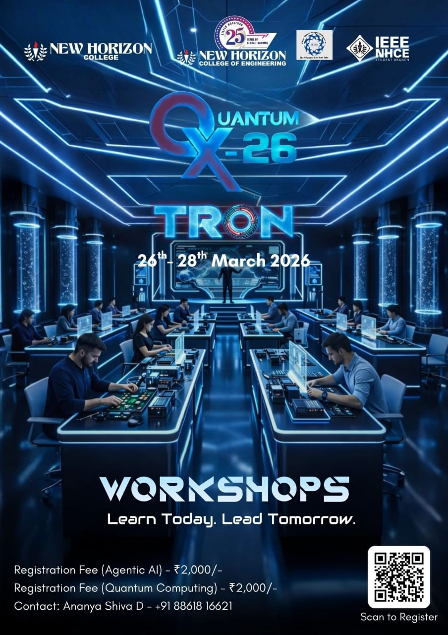

Photographs from the event:
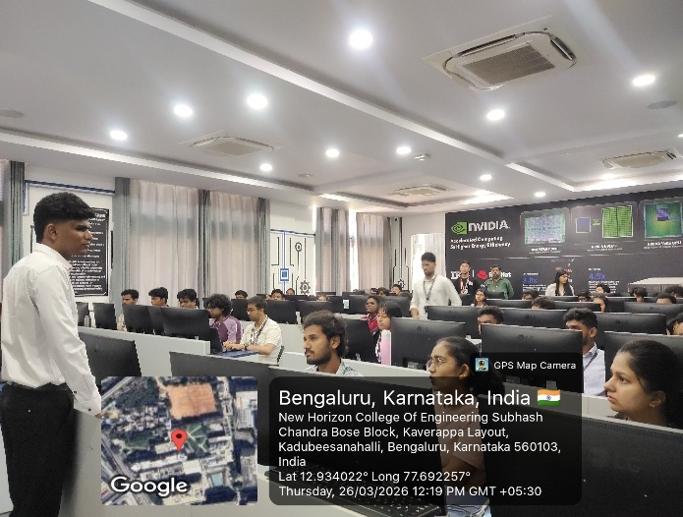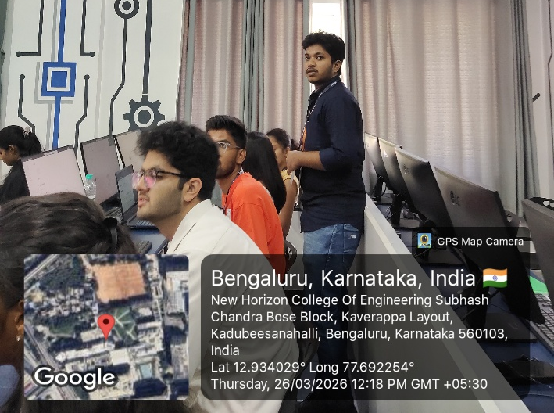
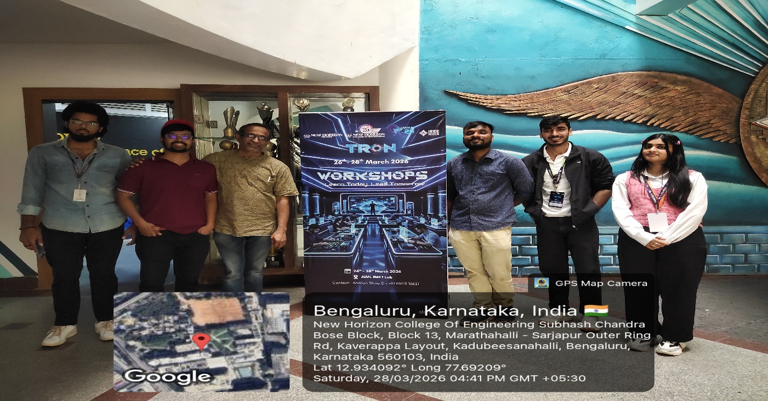
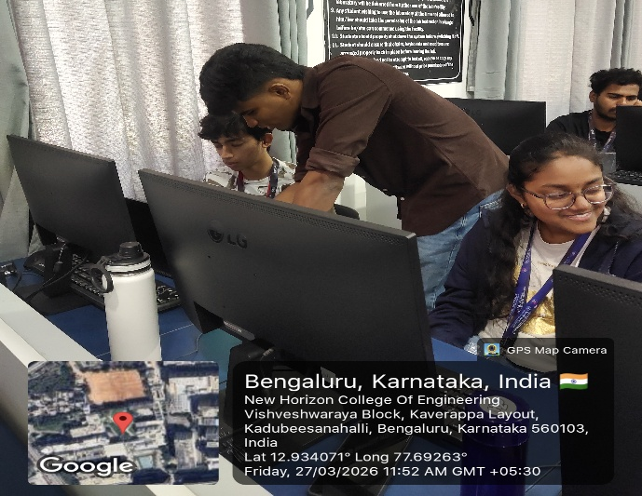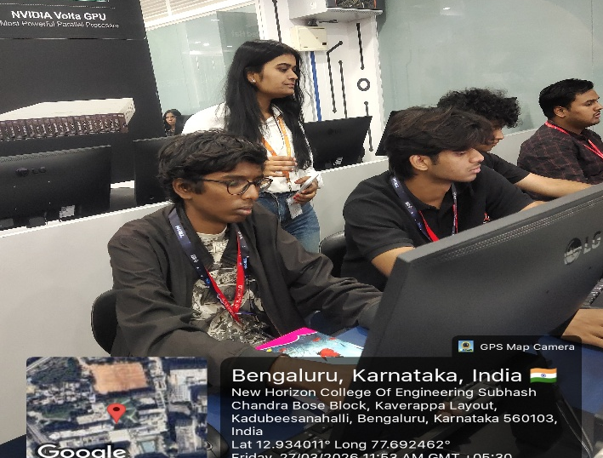
Feedback Analysis:
How would you rate your overall experience?  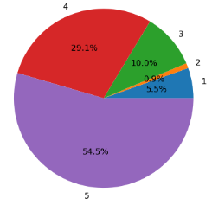 | How engaging was the event?  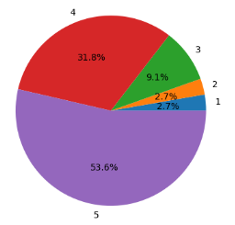
How challenging was the event?  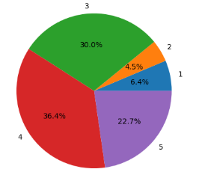 | Clarity of problem statements / tasks  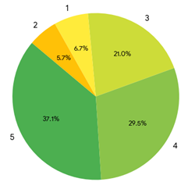
Time management and scheduling  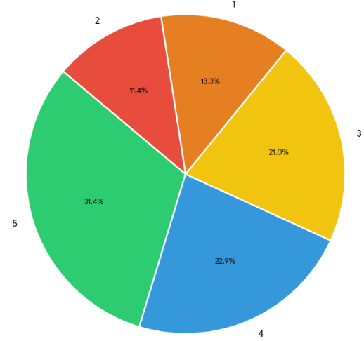 | Support from coordinators/mentor  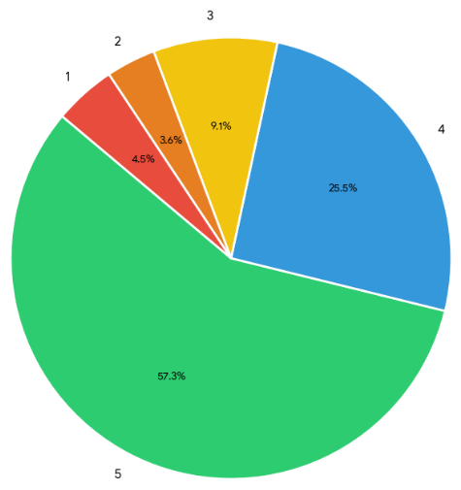

Summary:
The QuantumX 2026 event is a major initiative, and this workshop was conducted as one of its key sessions in collaboration with the FOSS Club at New Horizon College of Engineering. The workshop focused on Agentic AI and its real-world applications, providing valuable insights into autonomous AI systems along with hands-on exposure to relevant tools and concepts. It also covered data visualization using Microsoft Power BI and Tableau, and introduced prompt engineering techniques for effective interaction with AI systems. The FOSS Club students coordinated closely with the QuantumX team to ensure the successful organization and execution of the workshop. Overall, the session delivered a practical and informative learning experience, enhancing participants’ understanding of modern AI technologies.

Faculty Coordinator HOD-Hosting Dept.
Sathya.J Dr. V. Asha

REPORT BY: SUFIYA NOORAIN

