
NEW HORIZON COLLEGE OF ENGINEERING
EVENT NAME: RAPID BUILD: CODESPRINT
Organized By Department of MCA and FOSS Club

DATE: 05-12-2025
VENUE: MCA Lab 3
BRIEF DESCRIPTION OF THE EVENT
The DEPARTMENT OF MCA And FOSS Club organized an exciting 3-hour coding challenge titled “Rapid Build: CodeSprint”, aimed at encouraging creativity, quick thinking, and problem-solving abilities among students. The event was held on Friday, 5th Decemeber 2025. The event required participants to build a functional mini-project within the given time limit, integrating three random keywords provided at the beginning.

ABOUT THE EVENT
The event began with honouring the Team Members of Foss Club with Badges by the Faculty Members.
The participants had to form a team of 2 or 3 members. Each team had to spin the wheel to get their three keywords, which they had to incorporate meaningfully into their project either in the concept, logic, UI, or features.
Participants could use any programming language or framework. Internet usage and AI tools like ChatGPT were allowed only for assistance, not for generating full project solutions.
The total event duration was 3 hours, during which teams worked intensively on building, testing, and preparing their final project demos. They had to submit all the details in a google form along with screenshot of the project they worked on.
The event received enthusiastic participation from students across various branches. We had a total of 10 teams who participated in the event. Each team had 2 members. Teams showcased creativity through diverse technologies, ranging from web development and Python to innovative UI prototypes and mini-games.
After the coding period, each team presented a short demo of their project.
Judging was based on the following criteria:
- Creativity & Innovation
- Functionality
- Code Quality
- Presentation
- Effective Keyword Integration
The evaluation process was supervised by the team members.
Based on overall performance, the following teams secured the top positions:
- 1st Place: SUJITH and SUJAY | MCA 2nd year 3 Sem
- 2nd Place: SANDHYA.S and RATHNAPRIYA.A | MCA 1ST year, Sem I
- 3rd Place: KHUSHI KALINGE and MATEENA SADAF | AIML, 5 Sem
- 3rd Place: PAVITHRA SAI SOMA and NIVEDITHA.M.H | MCA 1ST year, Sem I
All other participants will receive E-Certificates in appreciation of their efforts and participation.
CONCLUSION
Rapid Build: CodeSprint proved to be an engaging and intellectually stimulating event that encouraged students to think creatively under time constraints. The keyword-based challenge added an element of surprise and innovation, leading to unique and impressive project outcomes.
The FOSS Club extends heartfelt thanks to Mrs. Sathya.J for her constant support and guidance, Mr. Mahesh for his technical support, and to all team members, teachers, and participants for contributing to the event’s success.

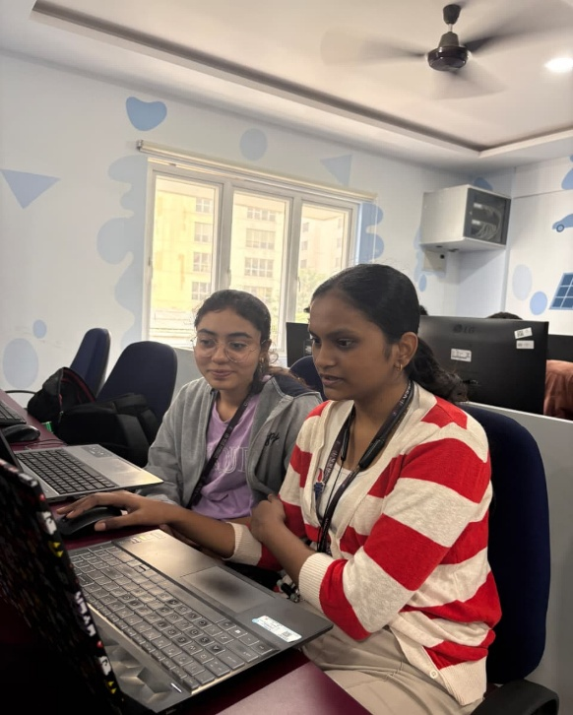
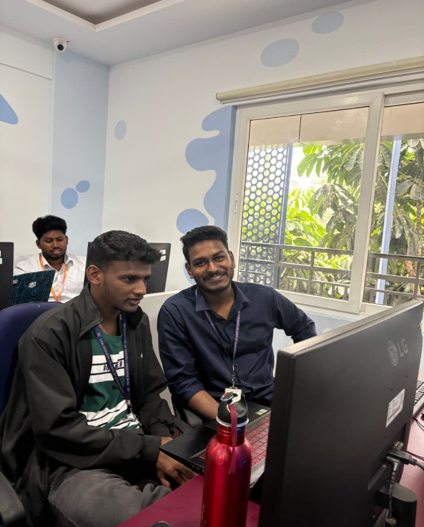
SNAPSHOTS FROM THE EVENT
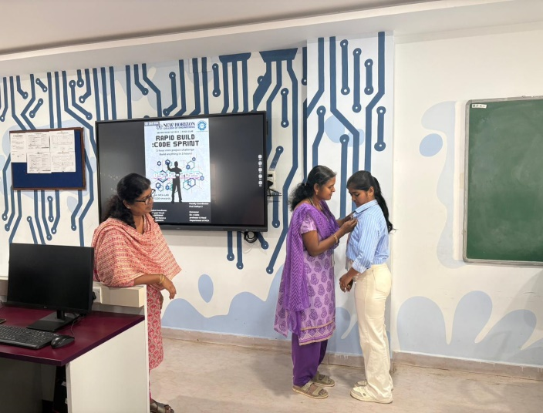
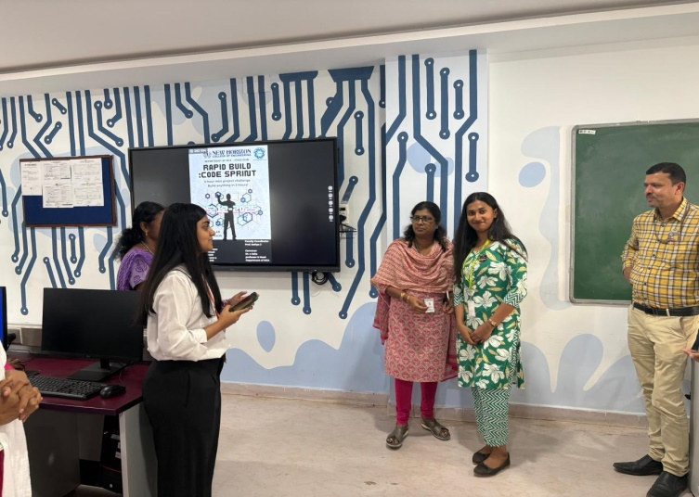
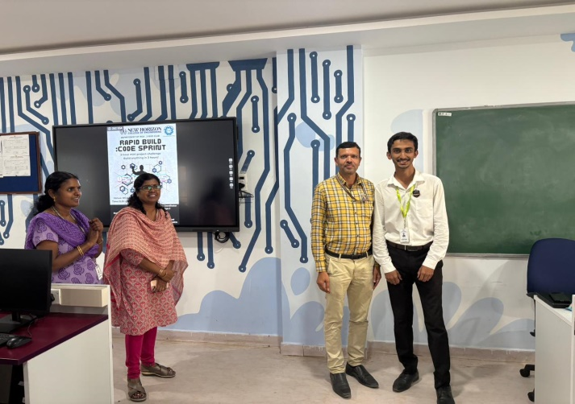
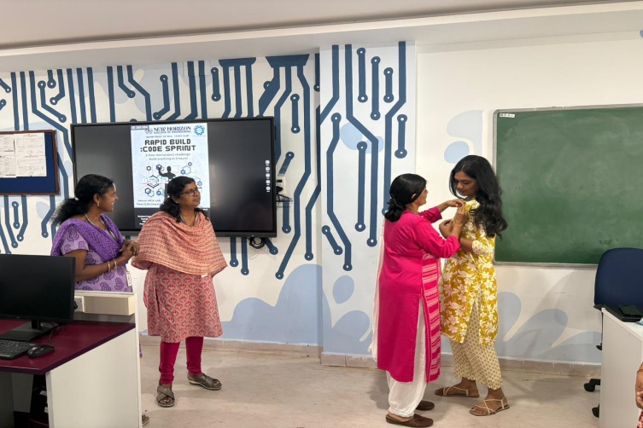
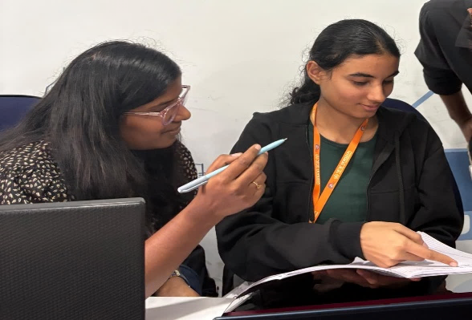
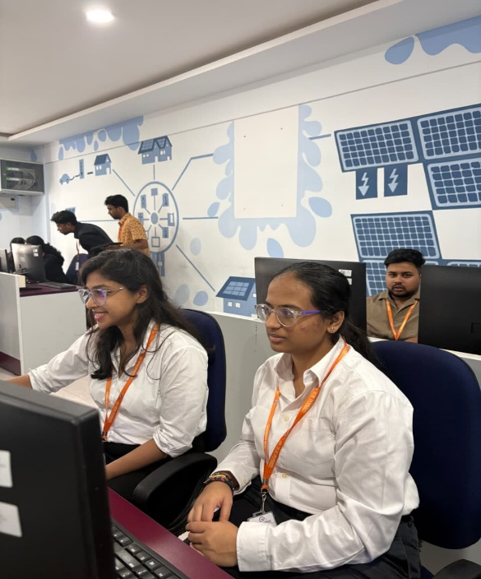
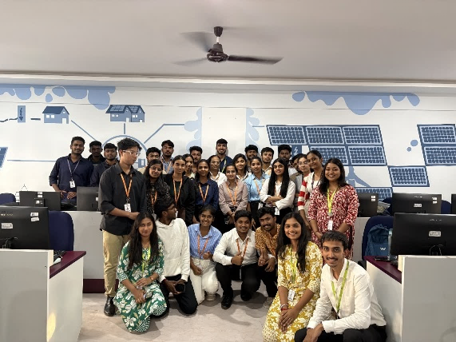
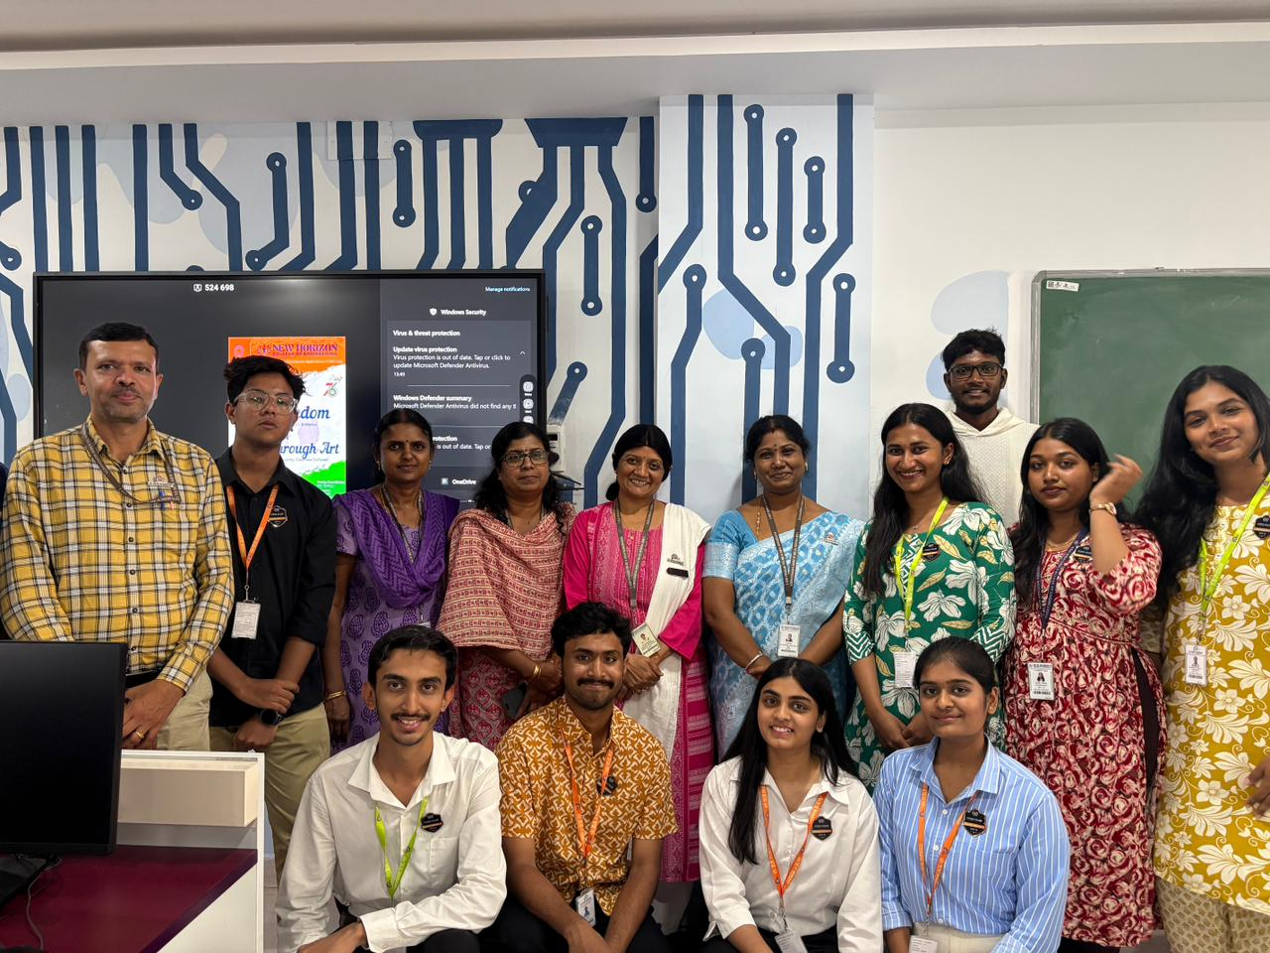

POSTER
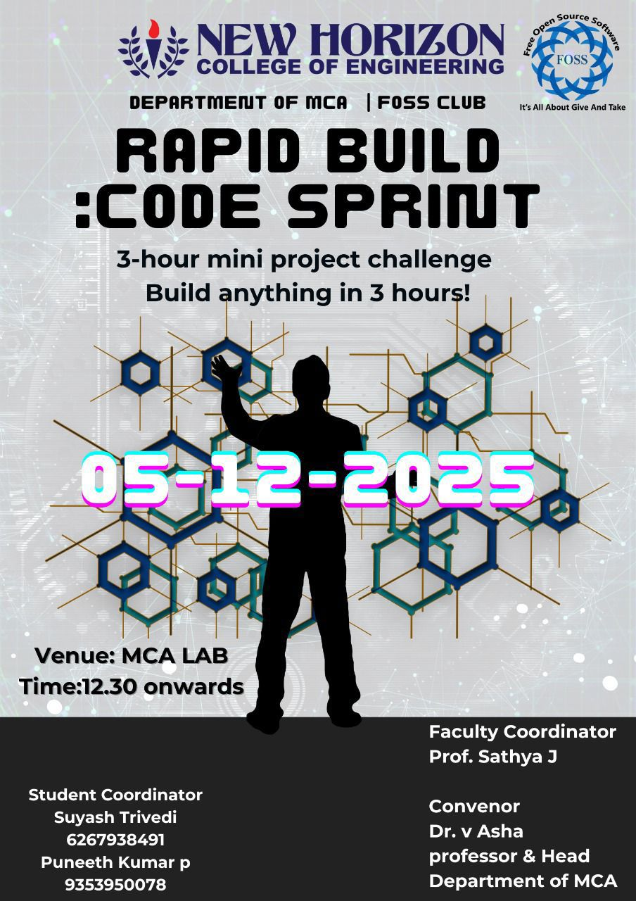

REGISTRATION FORM

REGISTRATION RESPONSES
Timestamp | Full Name | USN | Department | Sem & Section | E-mail Address | Phone No.
12-4-2025 12:03:27 | Sourabh Murudi | 25MCA158-T | MCA | I C | sourabhmurudi8@gmail.com | 8088022470
12-4-2025 13:27:14 | Aditya R Hadimani | 25MCA126-T | MCA | I A | adityahadimani007@gmail.com | 8147199396
12-4-2025 13:27:14 | Tejas Yankachi | 25MCA127-T | MCA | I C | tejas1122004@gmail.com | 8310230907
12-4-2025 13:55:37 | Simphe Gowda T V | 25MCA113 | MCA | I C | simphegowda1345@gmail.com | 6361224972
12-4-2025 16:03:07 | Rahul R | 25MCA036-T | MCA | I B | rahulr232003@gmail.com | 8971894247
12-4-2025 16:03:13 | M Tharun Raj | 25MCA037-T | MCA | I B | tharunrajpunith7@gmail.com | 8426893439
12-4-2025 16:05:35 | Pavithra Sai Soma | 25MCA100 | MCA | I B | pssoma8@gmail.com | 9108490959
12-4-2025 16:14:50 | Poornima Naikar | 25MCA116-T | MCA | I B | poornimanaikar4@gmail.com | 8792398481
12-4-2025 16:14:54 | Pratik s mungaravadi | 25MCA125-T | MCA | I B | Pratiksec56@gmail.com | 8296157586
12-4-2025 16:21:18 | Omkar D Powar | 25MCA054 | MCA | I B | omkarpowar004@gmail.com | 7411487006
12-4-2025 16:23:23 | Prerana Pandurang Majalikar | 25MCA056 | MCA | I B | preranamajalikar750@gmail.com | 7892395484
12-4-2025 18:14:36 | Tejas K M | 1NH24MC145 | MCA | III C | tejas.k.manjunath@gmail.com | 9902671757
12-4-2025 18:14:48 | Tanmay Rana | 1NH24MC142 | MCA | III C | tanmayrana2001@gmail.com | 9832525746
12-4-2025 20:12:20 | Sumit Singh | 1NH24MC136 | MCA | III C | sumitsinghnhce@gmail.com | 8861313243
12-4-2025 21:17:56 | Saarthak Kehri | 1NH24MC111 | MCA | III B | saarthakkehri@gmail.com | 9302290096
12-4-2025 22:59:54 | Mateena Sadaf | 1NH23AI092 | AIML | I B | mateenasadaf630@gmail.com | 8971373703
12-4-2025 23:01:25 | Khushi kalinge | 1NH23AI076 | AIML | I B | mateenasadaf630@gmail.com | 8971373703
12-5-2025 8:36:47 | RATHNAPRIYA.A | 25mca015 | MCA | I B | rathnapriyaarumugam@gmail.com | 8073729288
12-5-2025 8:57:31 | Sandhya S | 25MCA134-T | MCA | I C | sandhyasandy2904@gmail.com | 6363970386
12-5-2025 9:05:13 | Niveditha M H | 25MCA109-T | MCA | I B | nivedithamh2608@gmail.com | 7975131908
12-5-2025 10:36:41 | SUJAY M MUNDARAGI | 1NH24MC133 | MCA | III C | sujaymundaragi7@gmail.com | 8762338707
12-5-2025 10:56:02 | Nithya M | 25MCA149-T | MCA | I B | nithyam823@gmail.com | 7619445086
12-5-2025 10:57:31 | Manasa S | 25MCA101-T | MCA | I B | manasasampangi8@gmail.com | 7975145649
12-5-2025 12:10:22 | Sujith Lasrado | 1NH24MC134 | MCA | III C | sujithlasrado054@gmail.com | 8792063364

FEEDBACK FORM
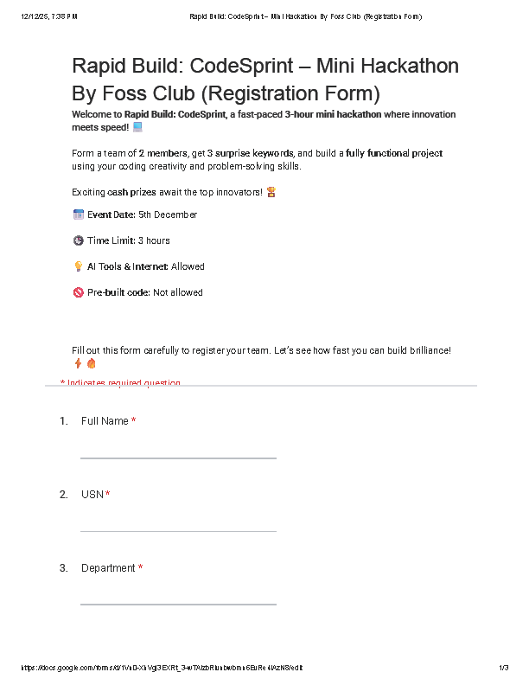

FEEDBACK RESPONSES
Full Name | USN | Department | Was the content relevant to your expectations and learning goals? | How challenging and engaging was the hackathon? | How satisfied are you with the event organization and time limit? | What did you enjoy the most about the event? | How would you rate the overall content of the event? | Suggestions & Comments
Sandhya S | 25MCA134-T | MCA | Yes | Moderate | Satisfied | Create and exploring new technologies | Good | Had a good experience
Rathnapriya.A | 25MCA015 | MCA | Yes | Moderate | Satisfied | We creating and exploring something new technologies. it was very good | Excellent | Over all good
Sourabh Murudi | 25MCA158-T | MCA | Yes | Tough but exciting | Satisfied | Good | Good | Good
Simphe Gowda T V | 25MCA113 | MCA | Yes | Moderate | Satisfied | Event idea was really good | Excellent | Good
Nithya M | 25MCA149-T | MCA | Yes | Tough but exciting | Satisfied | Participating in the event helped me to connect with new people and enjoyed creating project | Very Good | Had a very good experience
Manasa S | 25MCA101-T | MCA | Yes | Tough but exciting | Satisfied | Helped me think more critical and learnt new things. | Very Good | Interesting
Sujith Lasrado | 1NH24MC134 | MCA | Yes | Moderate | Satisfied | The keywords | Excellent | Its challenging and interesting
Prerana Majalikar | 25MCA056 | MCA | Yes | Moderate | Satisfied | Learnt creating projects and little bit of coding | Very Good | Nice Experience
Tejas Yankachi | 25MCA127-T | MCA | Yes | Moderate | Satisfied | Interface design | Excellent | Expecting more like this
Pratik m | U02IG22S0056 | MCA | Yes | Tough but exciting | Satisfied | Building website | Very Good | Good
Aditya R Hadimani | 25MCA126 | MCA | Yes | Moderate | Satisfied | Learning | Very Good | Looking forward for more event like this
Mateena Sadaf | 1NH23AI092 | AIML | Yes | Tough but exciting | Neutral | Good | Good | Nice Experience
M Tharun Raj | 25MCA037-T | MCA | Yes | Moderate | Satisfied | We had a crazy number of ideas but couldn't execute it properly | Excellent | Good and interesting
Rahul R | 25MCA036-T | MCA | Yes | Moderate | Neutral | Had crazy ideas but had no time to execute | Very Good | The time limit was very less I felt crazy during it
Pavithra Sai Soma, Niveditha M H | 25MCA100, 25MCA109 | MCA | Yes | Tough but exciting | Satisfied | Discussing ideas about the project to create | Excellent | Had a fun experience!
Poornima | 25MCA116 | MCA | Yes | Moderate | Satisfied | Website building | Very Good | Good
Omkar D Powar | 25MCA054 | MCA | Yes | Moderate | Neutral | Pc | Good | Good

FEEDBACK ANALYSIS

FACULTY CO-ORDINATOR HOD
SATHYA.J Dr.V.ASHA

